Experiment 1: Implement Selection sort using C language
Program:
#include <stdio.h>
void selectionSort(int arr[], int n) {// Function to perform selection sort
int i, j, min_idx, temp;
for (i = 0; i < n - 1; i++) {
min_idx = i;
for (j = i + 1; j < n; j++) {
if (arr[j] < arr[min_idx])
min_idx = j;
}
if (min_idx != i) {
temp = arr[i];
arr[i] = arr[min_idx];
arr[min_idx] = temp;
}
}
}
void printArray(int arr[], int n) {// Function to print an array
int i;
for (i = 0; i < n; i++)
printf("%d ", arr[i]);
printf("\n");
}
int main() {
int n, i;
printf("Enter number of elements: ");
scanf("%d", &n);
int arr[n]; // Create array of size n
printf("Enter %d elements:\n", n);
for (i = 0; i < n; i++) {
scanf("%d", &arr[i]);
}
printf("Original array: \n");
printArray(arr, n);
selectionSort(arr, n);
printf("Sorted array: \n");
printArray(arr, n);
return 0;
}
Output:
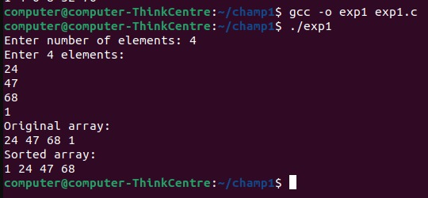

Experiment 2: Implement Insertion Sort using C language
Program:
#include <stdio.h>
// Function to perform insertion sort
void insertionSort(int arr[], int n) {
int i, key, j;
for (i = 1; i < n; i++)
{
key = arr[i]; // Element to be inserted
j = i - 1;
// Move elements of arr[0..i-1], that are greater than key,
// to one position ahead of their current position
while (j >= 0 && arr[j] > key)
{
arr[j + 1] = arr[j];
j = j - 1;
}
arr[j + 1] = key;
}
}
// Function to print an array
void printArray(int arr[], int n)
{
int i;
for (i = 0; i < n; i++)
printf("%d ", arr[i]);
printf("\n");
}
int main()
{
int n, i;
printf("Enter number of elements: ");
scanf("%d", &n);
int arr[n]; // Create array of size n
printf("Enter %d elements:\n", n);
for (i = 0; i < n; i++)
{
scanf("%d", &arr[i]);
}
printf("Original array: \n");
printArray(arr, n);
insertionSort(arr, n);
printf("Sorted array: \n");
printArray(arr, n);
return 0;
}
Output:
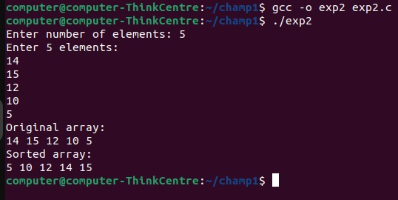
Experiment 3: Implement C Program for Binary Search using Divide and Conquer Approach
Program:
#include<stdio.h>
//Function to perform binary search
int binarySearch(int arr[], int left, int right, int key){
if(left>right)//base case
return -1;
int mid=left+(right-left)/2;
//if key is at middle index, return the index
if(arr[mid]==key)
return mid;
//If key is smaller than middle element
if(arr[mid]>key)
return binarySearch(arr, left, mid-1, key);
//If key is larger than middle element
return binarySearch(arr, mid+1, right, key);}
int main(){
int n, key;
printf("Enter the number of elements in the array: ");
scanf("%d", &n);
int arr[n];
printf("Enter the elements of array in ascending order:\n");
for(int i=0;i<n;i++)
scanf("%d", &arr[i]);
printf("Enter the key value to search for: ");
scanf("%d", &key);
//Call binarySearch to search for key
int result=binarySearch(arr,0, n-1, key);
//Print the result
if(result!=-1)
printf("Element found at index: %d\n", result);
else
printf("Element not found.\n");
return 0;
}
Output:
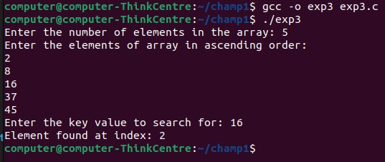

Experiment 4: Implement Merge sort using C language
Program:
#include <stdio.h>
// Function to merge two halves
void merge(int arr[], int left, int mid, int right) {
int n1 = mid - left + 1; // Size of left subarray
int n2 = right - mid; // Size of right subarray
int L[n1], R[n2]; // Temporary arrays
// Copy data to temp arrays
for (int i = 0; i < n1; i++)
L[i] = arr[left + i];
for (int j = 0; j < n2; j++)
R[j] = arr[mid + 1 + j];
int i = 0, j = 0, k = left;
// Merge the temp arrays back into arr
while (i < n1 && j < n2) {
if (L[i] <= R[j]) {
arr[k] = L[i];
i++;}
else {
arr[k] = R[j];
j++;}
k++;}
// Copy any remaining elements of L[]
while (i < n1) {
arr[k] = L[i];
i++;
k++;}
// Copy any remaining elements of R[]
while (j < n2) {
arr[k] = R[j];
j++;
k++;}
}
// Function to perform merge sort
void mergeSort(int arr[], int left, int right) {
if (left < right) {
int mid = left + (right - left) / 2; // Avoids overflow
mergeSort(arr, left, mid); // Sort first half
mergeSort(arr, mid + 1, right); // Sort second half
merge(arr, left, mid, right); // Merge the sorted halves
}
}
// Function to print an array
void printArray(int arr[], int n) {
for (int i = 0; i < n; i++)
printf("%d ", arr[i]);
printf("\n");
}
int main() {
int n;
printf("Enter number of elements: ");
scanf("%d", &n);
int arr[n];
printf("Enter %d elements:\n", n);
for (int i = 0; i < n; i++)
scanf("%d", &arr[i]);
printf("Original array:\n");
printArray(arr, n);
mergeSort(arr, 0, n - 1);
printf("Sorted array:\n");
printArray(arr, n);
return 0;
}
Output:
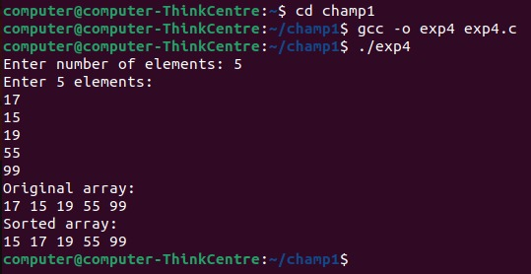

Experiment 5: Implement Fractional Knapsack problem using C language
Program:
#include <stdio.h>
#include <stdlib.h>
struct Item {
int value, weight;
};
// Compare items by value/weight ratio (descending)
int cmp(const void* a, const void* b) {
double r1 = (double)((struct Item*)a)->value / ((struct Item*)a)->weight;
double r2 = (double)((struct Item*)b)->value / ((struct Item*)b)->weight;
return (r2 > r1) - (r2 < r1);
}
double knapsack(int cap, struct Item arr[], int n) {
qsort(arr, n, sizeof(struct Item), cmp);
double val = 0.0;
for (int i = 0; i < n && cap > 0; i++) {
if (arr[i].weight <= cap) {
cap -= arr[i].weight;
val += arr[i].value;
}
else {
val += arr[i].value * (double)cap / arr[i].weight;
break;
}
}
return val;
}
int main() {
int n, cap;
printf("Enter number of items: ");
scanf("%d", &n);
printf("Enter knapsack capacity: ");
scanf("%d", &cap);
struct Item items[n];
for (int i = 0; i < n; i++) {
printf("Enter value and weight for item %d: ", i + 1);
scanf("%d %d", &items[i].value, &items[i].weight);
}
printf("\nMaximum value in Knapsack = %.2f\n", knapsack(cap, items, n));
return 0;
}
Output:
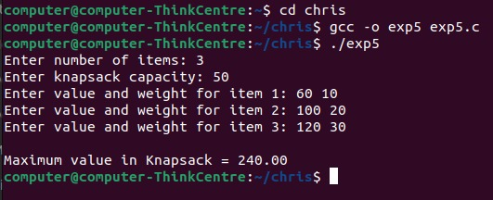

Experiment 6: Implement Minimum cost spanning tree-Kruskal using C language
Program:
#include <stdio.h>
#include <stdlib.h>
typedef struct { int u,v,w; } Edge;
int p[100];
int find(int x)
{
return p[x]==x?x:(p[x]=find(p[x]));
}
int cmp(const void *a,const void *b)
{
return ((Edge*)a)->w-((Edge*)b)->w;
}
int main(){
int V,E;
printf("Enter the number of vertices: ");
scanf("%d",&V);
printf("Enter the number of edges: ");
scanf("%d",&E);
Edge e[E];
printf("Enter each edge as: source destination weight\n");
for(int i=0;i<E;i++){
printf("Edge %d: ",i+1);
scanf("%d%d%d",&e[i].u,&e[i].v,&e[i].w);
}
for(int i=0;i<V;i++)
p[i]=i;
qsort(e,E,sizeof(Edge),cmp);
int cost=0,c=0;
printf("\nEdges in the Minimum Spanning Tree:\n");
for(int i=0;i<E&&c<V-1;i++)
if(find(e[i].u)!=find(e[i].v)){
printf("%d -- %d == %d\n",e[i].u,e[i].v,e[i].w);
cost+=e[i].w; p[find(e[i].u)]=find(e[i].v); c++;
}
printf("Total cost of MST: %d\n",cost);
}
Output:
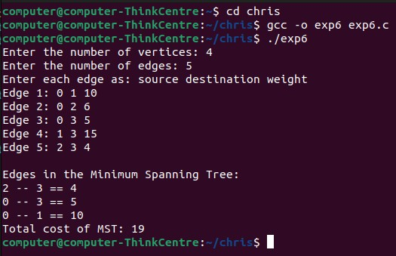

Experiment 7: Implement All pair shortest path – Floyd Warshall using C language
Program:
#include <stdio.h>
#include <string.h>
#include <stdlib.h>
#define INF 99999
void floydWarshall(int n, int dist[][n]) {
for (int k = 0; k < n; k++)
for (int i = 0; i < n; i++)
for (int j = 0; j < n; j++)
if (dist[i][k] + dist[k][j] < dist[i][j])
dist[i][j] = dist[i][k] + dist[k][j];
printf("\nShortest distances between every pair of vertices:\n");
for (int i = 0; i < n; i++) {
for (int j = 0; j < n; j++) {
if (dist[i][j] == INF)
printf("%5s", "INF");
else
printf("%5d", dist[i][j]);
}
printf("\n");
}
}
int main() {
int n;
printf("Enter number of vertices: ");
scanf("%d", &n);

int graph[n][n];
char temp[20];
printf("Enter adjacency matrix (use INF for no edge):\n");
for (int i = 0; i < n; i++) {
for (int j = 0; j < n; j++) {
scanf("%s", temp);
if (strcmp(temp, "INF") == 0)
graph[i][j] = INF;
else
graph[i][j] = atoi(temp);
}
}
floydWarshall(n, graph);
return 0;
}
Output:
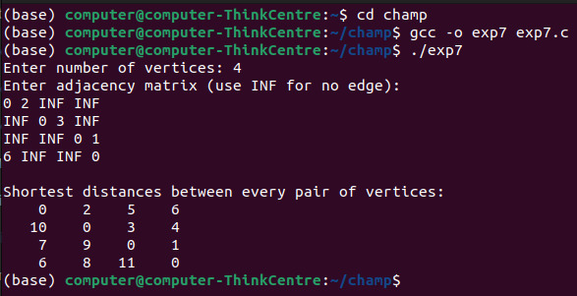

Experiment 8: Implement Longest common subsequence using C language
Program:
#include <stdio.h>
#include <string.h>
// Function to find max of two numbers
int max(int a, int b) {
return (a > b) ? a : b;
}
// Function to compute LCS
void LCS(char X[], char Y[]) {
int m = strlen(X);
int n = strlen(Y);
int dp[m + 1][n + 1];
// Build LCS table in bottom-up manner
for (int i = 0; i <= m; i++) {
for (int j = 0; j <= n; j++) {
if (i == 0 || j == 0)
dp[i][j] = 0;
else if (X[i - 1] == Y[j - 1])
dp[i][j] = 1 + dp[i - 1][j - 1];
else
dp[i][j] = max(dp[i - 1][j], dp[i][j - 1]);
}
}
// Length of LCS
int length = dp[m][n];
printf("Length of LCS: %d\n", length);

// Backtrack to find LCS string
char lcs[length + 1];
lcs[length] = '\0';
int i = m, j = n, index = length - 1;
while (i > 0 && j > 0) {
if (X[i - 1] == Y[j - 1]) {
lcs[index--] = X[i - 1];
i--; j--;
} else if (dp[i - 1][j] > dp[i][j - 1])
i--;
else
j--;
}
printf("LCS: %s\n", lcs);
}
int main() {
char X[100], Y[100];
printf("Enter first string: ");
scanf("%s", X);
printf("Enter second string: ");
scanf("%s", Y);
LCS(X, Y);
return 0;
}

Output:
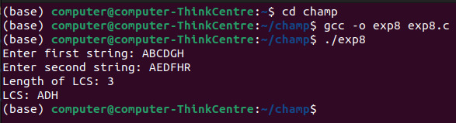

Experiment 9: Implement Sum of subsets using C language
Program:
#include <stdio.h>
int n, target;
int set[20], subset[20];
void displaySubset(int size) {
printf("{ ");
for (int i = 0; i < size; i++)
printf("%d ", subset[i]);
printf("}\n");
}
void sumOfSubsets(int index, int currentSum, int subsetSize) {
if (currentSum == target) {
displaySubset(subsetSize); // Found a valid subset
return;
}
if (index == n || currentSum > target)
return;
// Include current element
subset[subsetSize] = set[index];
sumOfSubsets(index + 1, currentSum + set[index], subsetSize + 1);
// Exclude current element
sumOfSubsets(index + 1, currentSum, subsetSize);
}
int main() {
printf("Enter number of elements: ");
scanf("%d", &n);
printf("Enter elements of the set:\n");
for (int i = 0; i < n; i++)
scanf("%d", &set[i]);
printf("Enter target sum: ");
scanf("%d", &target);
printf("Subsets with sum %d are:\n", target);
sumOfSubsets(0, 0, 0);
return 0;
}
Output:
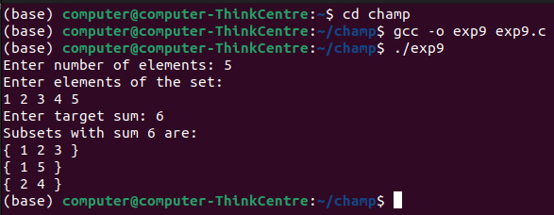

Experiment 10: Implement Naïve string-matching Algorithms using C language
Program:
#include <stdio.h>
#include <string.h>
void naiveStringMatch(char text[], char pattern[]) {
int n = strlen(text);
int m = strlen(pattern);
printf("Pattern found at positions: ");
int found = 0;
for (int i = 0; i <= n - m; i++) {
int j;
for (j = 0; j < m; j++) {
if (text[i + j] != pattern[j])
break;
}
if (j == m) {
printf("%d ", i); // pattern found at index i
found = 1;
}
}
if (!found)
printf("None");
printf("\n");
}
int main() {
char text[100], pattern[50];
printf("Enter the text: ");
scanf("%[^\n]", text); // read full line including spaces
getchar(); // consume newline
printf("Enter the pattern to search: ");
scanf("%[^\n]", pattern);
naiveStringMatch(text, pattern);
return 0;
}
Output:
